Neshaminy School District

2001 Old Lincoln Highway •Langhorne, Pennsylvania 19047-3295

Robert L. Copeland

Superintendent of Schools

August 29, 2014

Dear Parents/Guardians:



The goal for literacy instruction in Neshaminy School District is to ensure that all students become proficient and critical readers and writers, motivated to read and write throughout their lives.

To achieve this goal, the elementary and middle school literacy program is based on a comprehensive, balanced approach, in which reading and are regarded as complementary processes that promote higher level thinking skills. Balanced Literacy is based on extensive research in best practices in reading and writing instruction.

As part of the Balanced Literacy program, our middle schools are implementing a workshop approach to reading and writing. A workshop approach follows the premise that to grow as a

reader and writer, a student needs to be spending as much time as possible reading and writing. Daily lessons taught by the teacher focus on strategies that advance this development.

You may find that your child's experience in reading and English classes is different than your experiences in school. The greatest difference will be in the length of the lesson presented by the teacher, the amount of choice in independent reading, and the amount of reading and writing that is expected from students. Another difference will be in the feedback your child receives, which comes through conferences with the teacher. The feedback is given frequently and in the case of writing, will be prior to a piece of writing being submitted for a grade.

We look forward to an exciting and rigorous year of learning for all of our middle school students.

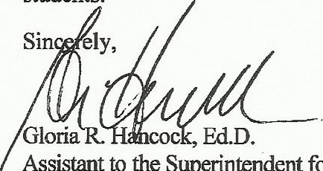Assistant to the Superintendent for

Curriculum, Instruction and Assessment

Neshaminy Distria -

Nesha-niny l¾h215-809-8100.Map.e PointMiddle 215-609&30 • Paqæss:ng 2158096210 can Sandburg Middle215-809-Q20

Buck Elem. 215-809-6300 • San•uel Evenn Elem. 215-809-6320 Oliver Heckman Elem. 215-809-6330 • Herbert Hoover Elem. 215-809-5340 • Southampton Elem. 215-809-6350

Walter Miller Elem. 215809-6360 Josem Fererbar Elen Abert S&Mùer Elem 215-809£3EO